C64 WiFi-Modem for User Port Rev. 1

Module Description

This board is a WiFi modem for the User Port of the Commodore C64. It is based on the project “Build your own 9600 Baud C64 WiFi Modem For $10” of “1200BAUD” (<https://1200baud.wordpress.com/2017/03/04/build-your-own-9600-baud-c64-wifi-modem-for-20/>).

The WiFi functionality is implemented in the NODEMCU V3 development board/module, which contains an Espressive ESP8266, a WiFi and RISC processor. This module can be programmed with free software via a micro USB cable.

The board contains status and activity LEDs and connects to the User Port of the Commodore C64.

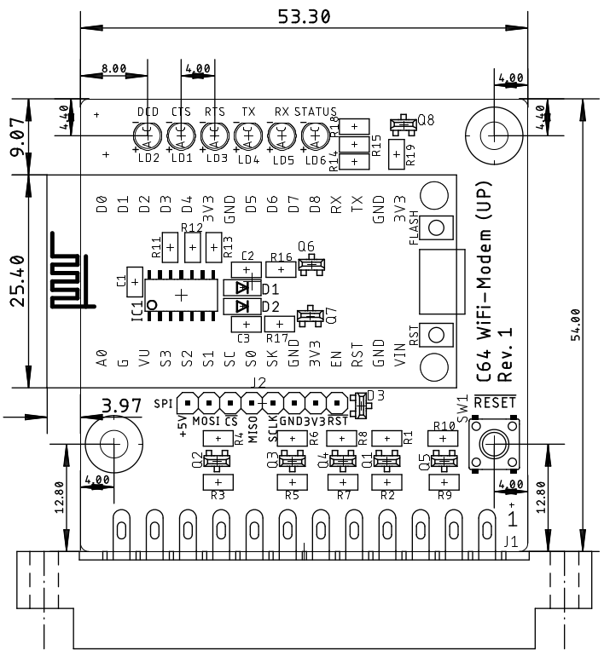

Figure 1: Dimensions of the WiFi modem board

For the NodeMCU V3 programming and the required C64 software, refer to the article mentioned before.

The board contains level shifters, that translate between the NodeMCU 3.3V level and the User Port 5V level. According to the data sheet, the ESP8266 is not 5V-level tolerant. Its protection diodes might limit the HIGH level to below 4V. Without the level shifters, the User Port/6526 CIA might be stressed by the HIGH level being pulled to this level.

# Logic connections

| 3.3V level | |  | 5V level | |
| --- | --- | --- | --- | --- |
| Pin | NodeMCU V3 | Signal | User Port | Pin |
| 29 | GPIO5 (D1) | RTS | PB1 | D |
| 28 | GPIO4 (D2) | CTS | PB6 | K |
| 26 | GPIO2 (D4) | DCD | PB4 | H |
| 22 | GPIO12 (D6) | Status-LED | - | - |
| 19 | RXD0 (RX) | RXD | PA2, SP1 | M, 5 |
| 18 | TXD0 (TX) | TXD | /FLAG2, PB0, SP2 | B, C, 7 |
| - | - |  | PB7, CNT2 | L, 6 |

# Connectors

## User Port

2 x 12 edge connector, pitch 3.96mm

|  |  |  |  |
| --- | --- | --- | --- |
| Pin | Signal | Pin | Signal |
| 1 | GND | A | GBD |
| 2 | +5V | B, C | TXD |
| 3 |  | D | RTS |
| 5 | RXD | H | DCD |
| 6 | CNT2 | K | CTS |
| 7 | TXD | L | CNT2 |
| 12 | GND | M | RXD |
|  |  | N | GND |

## SPI (spare)

8p. pin header, pitch 2.54mm. The function of the SPI-Bus is not implemented in the NodeMCU software. The signals have a 3.3V level. 3.3V, 5V and GND are connected to this pin header.

|  |  |
| --- | --- |
| Pin | Signal |
| 1 | +5V |
| 2 | MOSI |
| 3 |  |
| 4 | MISO |
| 5 | SCLK |
| 6 | GND |
| 7 | +3.3V |
| 8 | (Reset Signal NodeMCU) |

# Revision History

## Rev. 0

Prototype, functional. Labeling of the LEDs was not perfect, the Status LED was inverted.

## Rev. 0 → Rev. 1

* Board Revision
* LEDs changed to 3mm standard LEDs
* The “WiFi” LED is now named “Status” and it is inverted
* The Labeling from RX and TX was swapped, since before it was labeled from the perspective of the NodeMCU
* Positions of LEDs have moved
* A pin header for a spare SPI-Bus connection is added
* Two mounting holes for a not yet designed enclosure are added
* A -Button is added
* The C64 Reset affects the NodeMCU